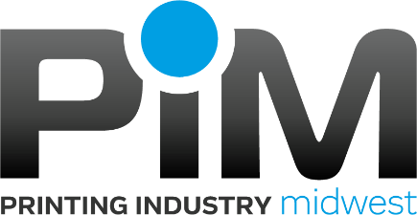
Community Based Organizations (Community Based Organizations)

These are suggested CBO’s to work with in your efforts to become a PIM Diversity Inclusive Company these CBO’s may assist in helping you find and employ People of Color. PIM will also help you locate local CBO’s in your area.

Minnesota
- American Indian OIC: https://www.facebook.com/AmericanIndianOIC/
- Avivo: - https://avivomn.org/ 612-752-8000
- Brooklynk: https://www.brooklynk.works/ Catrice O’Neal Catrice.ONeal@brooklynk.works 763-493-8029
- Minncor: https://mn.gov/doc/ Alan Larson alan.larson@state.mn.us (218)485-5028
- Step Up: https://www.achievempls.org/stepup Mariah Colucci mcolucci@achievempls.org Ashley Krell agrell@achievempls.org
- Twin Cities Rise: https://www.twincitiesrise.org/employers
- Urban League Twin Cities: https://ultcmn.org/about-us/our-mission/
- Women Venture: https://www.womenventure.org
- Right Track: Right Track | Saint Paul, Minnesota (stpaul.gov) Nardos Tesfalidet nardos.tesfalidet@cit.stpaul.mn.us 651-266-6509
Midwest
- Goodwill Industries - https://www.goodwilleasterseals.org/ Cassandra Avery CAvery@gesmn.org or Becky Brink BBrink@gesmn.org 612-741-5778. This is Minnesota, but may be able to contact to find local assistance for where your company is located.
- Junior Achievement https://jausa.ja.org/ locate your local JA – to work with directly and find contact information.
- National Association for Advancement of Colored People https://www.naacp.org/ locate your local NAACP – too work with directly and find contact information
- Urban League - https://nul.org/ locate your local Urban League connection
- YMCA - https://www.ymca.net/ locate your local YMCA

Government Partners in Employment
Iowa
Iowa Workforce Development https://www.iowaworkforcedevelopment.gov/business - there is a current ex offender initiative https://www.iowaworkforcedevelopment.gov/ex-offender-initiative
Minnesota
Minnesota Career Force Centers https://www.careerforcemn.com/
Nebraska
Nebraska Department of Labor https://www.dol.nebraska.gov/EmploymentAndTraining
North Dakota
North Dakota Labor & Human Rights https://www.nd.gov/labor/education-and-other-resources
South Dakota
South Dakota Employment https://sd.gov/employment.aspx

