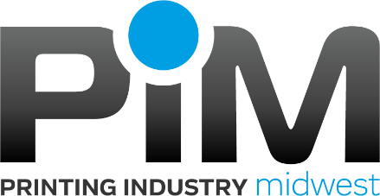

**Sales Tax Rate Lookup**

**Iowa:**

<https://lge.iowa.gov/SalesTaxRate.html>

Printer exemption: <https://tax.iowa.gov/iowa-sales-tax-and-printers-and-publishers>

**Minnesota:**

<http://www.revenue.state.mn.us/businesses/sut/Pages/SalesTaxCalculator.aspx>

FAQ for remote sellers: [here](http://www.revenue.state.mn.us/Pages/FAQ.aspx?WebId=5e2267cd-5aa2-479e-916e-bfe0731c9623&Owner=Sales%20and%20Use%20Tax&Topic=Tax%20Information&SubTopic=Streamlined%20sales%20tax%20information)

**Nebraska:**

<http://www.revenue.nebraska.gov/ratefinder.html>

**North Dakota:**

<https://apps.nd.gov/tax/tap/_/#1>

**South Dakota:**

<https://apps.sd.gov/rv25taxmatch/main.aspx>