Lean – Applied to the Value Chain

As stated in previous articles in this series, lean is defined as “the right thing in the right place at the right time” Reliability of process outcomes is the goal; this concept applies not just to internal operations. It applies to the entire value chain – consumer to customer to your company into your supply base. Everything.

Unless your organization is on the brink of failure, i.e., going bankrupt, lean should be used as a mechanism to grow the organization profitably, not to cut labor, find the cheapest suppliers, take any order from anybody, etc. Getting “A” players in the value chain makes all of the corresponding information and product flow processes so much simpler. Companies work together as teams, resulting in high performance value chains – where every company involved wins.

Information from Customers

Customers provide various types of information to your business so you can make what they want and send it to them how they want it. Exact colors, due dates, quantities, sizes, delivery information, etc. In lean, wait time is critical and it applies here in this way – how long do your customers sit on information you need to produce an order before they send that information to you? List your customers by volume and then how easy they are to work with. Start with a decent sized customer that is easy to work with and see if you can speed up information flow. A few days lost in the communication of this information is equal to the days lost inside your own company.

Develop a simple checklist of all of the information needed from customers. Use it when they place an order. This saved follow-up calls, confusion in the shop and ordering from suppliers, etc. Then rapidly disperse this information to the people that need it – avoiding wait time.

Internal Processing Times

Once you have accurate and organized information to work with, orders should be able to be processed efficiently and quickly within your own company. Measure the duration between order receipt and start/finish of production and also the ordering of materials from suppliers.

You can do simple flow diagrams to map the flows. But make sure you also put into the flow diagram the move and wait times as that is what you are trying to eliminate/reduce. Most companies only map the value-added steps. Include the waste so it is evident and can be addressed. In most companies, wait times represent 95% or more of the total process cycle time.

Supplier Factors

Supplier lead times, quality, on-time delivery are factors that you need to strive for in lean. Reduce wait time in information flows from your company to the supplier. Many times, this information can be immediate from the receipt of information from your customer. Every minute counts. Use reliable suppliers that are in your area to reduce transit times. Eliminate minimum order quantities – do not reward them because they are not efficient. You are their customer. They should do what you want. Just like you do for your customers.

Example Case

I will summarize (briefly) how working on a value chain issue with Coca-Cola ended up saving them $50,000,000 per year just working with their fast-food customers. They changed from working with six “cheap” printing and kitting suppliers for different items (such as paper cups, French fry bags, window clings, etc.) to one supplier that could do everything. The combination of Coca-Cola’s suppliers needed 16 weeks to get all of the products made, kitted and shipped. But the restaurants Coca Cola supplied to only needed to place their orders to Coca-Cola 8 weeks before delivery, so Coca-Cola had to guess at how much product would be needed. We shortened the information flow to suppliers to be less than 1 week and production took 3 weeks, so we could get all of the restaurant orders and then submit the desired fulfillment quantity to the supplier, with four weeks to spare. This reduced over-production waste by $50,000,000 annually. In summary, wait time, move time and over-production were all reduced to fit the fulfillment timeline. One of the tools we used to analyze this problem is shown below.

Value Chain Flow Map

Below is a simplified example of a flow diagram that covers both information and product flows. Both are important. Be sure to include the information flows because they are often overlooked.

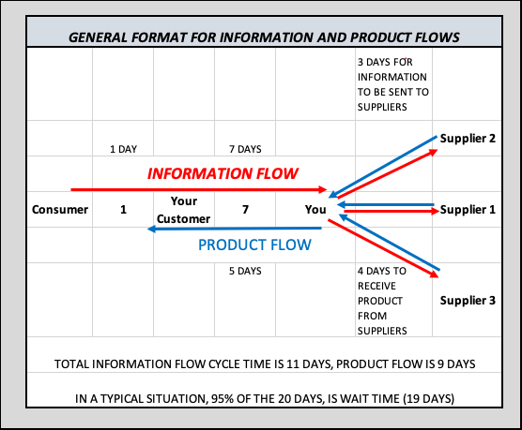

Conclusion

Lean applies throughout the value chain. Not just to internal processes in your company. Value chains ultimately compete for the final consumer. Use the mapping to address issues within your company, then expand to include suppliers and customers. Eliminating waste throughout the value chain is a key to market domination.

_______

About the Author: Bob Krausert is the owner of STRATEX, a Twin Cities based firm that works nationwide. Bob is the author of the book, Extreme Lean, published in 2018. Bob has worked with over 60 printing companies, mostly mid-sized companies, but also with larger companies like Jostens and RR Donnelly. During his career, Bob has trained over 12,000 people at both public and private events. Bob has been working with PIM since 2010, periodically providing educational seminars for its members. Bob can be reached at stratexlean20@gmail.com or by phone at 612-743-8706. If you would like to have a specific question or topic covered in one of the monthly articles, feel free to make the suggestion!

