Understanding Your Workforce Capabilities – The Skills Matrix

Your printing business relies on printing presses, die cut machines, etc. to generate revenue for the company. Similarly, you need skilled labor to effectively complete the activities required run the machines, etc., to generate good product on time. How good is your workforce and where are the risks within that workforce for your company?

It is important that the management team clearly and objectively understands the workforce’s capabilities. Too frequently management teams try to save money by having less skilled workers or say it is difficult to find skilled workers for important positions. But where do you need the workers to have the most skills? What does it cost you to have a mediocre workforce in critical parts of the company?

Skills Matrix

Below is an abbreviated skills matrix example. In the real world, you would have the different categories of machines, etc. listed, not just one category like below. Different presses, die cutting, pre-press skills, etc. Fundamental to this is to make sure you use a color-coded system, not numbers because with numbers you need to look at each individual cell to see what is exactly there. With colors, the skill levels become quite evident.

There are two ways to use this matrix at the start (you can eventually modify it in different ways to do more analysis of workforce risks, such as learning curves, cost of inexperienced labor, etc. The next article will cover how to do those types of analyses). But to get started, agree on the core of the skills matrix itself. Don’t go overboard on the number of activities for each category. This example has four activities for the press. Making this too complex and too detailed also makes it worthless.

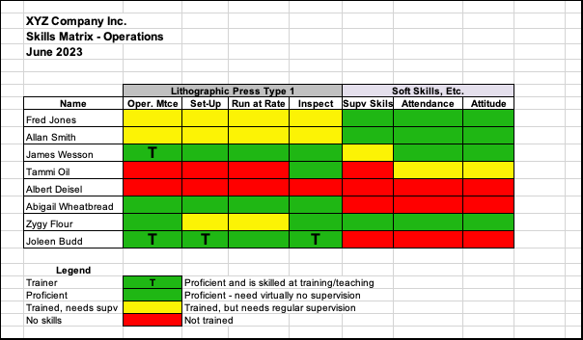

You can split this skills matrix into locations, types of equipment, different work shifts, etc. Again, don’t over-complicate.

The initial thing is to be objective in assigning the colors to a person. Green is you KNOW they can do the job properly. Red is they can’t do it or can’t do it without significant handholding. Yellow is everything else. Don’t over-analyze! Regardless of what you come up with it will not be perfect as skills are an interpretation of what you think people can do. Just be practical and fair.

Once you have the colors filled in, take a look at it from several perspectives. One, look where there is an overconcentration of skills with one person – that is a risk for the company if that person were to leave. You see this by reading horizontally across the matrix.

Reading vertically, you see how a category is set for skills that it needs to operate. For example, if this company had 3 of the Lithographic presses in the category listed, it probably has sufficient coverage. If it has 6 machines, there is a decent risk that the machines are under-utilized.

Summary

Just be objective with your ratings for each individual on the matrix. Have relevant categories. Then list 3-4 key activities for the category. Once the basics are set up, it shouldn’t take that long to fill in. Green is proficient – can give the job to that person and it will get done correctly without supervision. Red is you probably wouldn’t assign it to someone. Yellow is everything else. Then analyze your workforce and take the actions you need to do to improve it. Have actions and accountability and metrics to make the skills improvements a reality.

An under skilled workforce results in lost capacity for that activity or machine, etc. Think of opportunity and what difference it would make if each machine in your shop had 20% more capacity because your workers have the right critical skills. This capacity increase equates to better cash flow, better delivery performance and more than likely, reduced expenses.

_______

About the Author: Bob Krausert is the owner of STRATEX, a Twin Cities based firm that works nationwide. Bob is the author of the book, Extreme Lean, published in 2018. Bob has worked with over 60 printing companies, mostly mid-sized companies, but also with larger companies like Jostens and Banta, now part of RR Donnelly. During his career, Bob has trained over 12,000 people at both public and private events. Bob has been working with PIM since 2010, periodically providing educational seminars for its members. Bob can be reached at stratexlean20@gmail.com or by phone at 612-743-8706. If you would like to have a specific question or topic covered in one of the articles, feel free to make the suggestion.

