Aligning Your Operations to Market Requirements

There are a lot of businesses where the owners and management sort of understand what their value proposition is for their customers and sort of understand what their customers expect from them. That is not good enough to dominate a desired market or grow profitably. Almost all printing companies have unique equipment or capabilities, the newest press or the fastest delivery or the low prices. It would seem like these things should be important to all customers, but in many cases they are not. Not only that, but if you asked your management team to list the types of customers that you serve and what they want/need from you, you would have 5 different answers if there were five different people that were asked.

For example, with in-store signing, do Target, Walmart, The Home Depot, Tom’s Shoe Store, a local grocery store chain with 5 stores, all want the same thing? They’re all retailers so why wouldn’t they? How about printing for Coca-Cola, Abbott Labs, Weyerhaeuser, Hormel Foods, IBM, US Bank, Chase Bank, Burger King, Subway, the IRS? Different industries will have different needs. Different companies in the same industry will have different needs. You need to understand these needs so that you can offer top of the line services and products to support the needs of your customer.

Example – Retail Chains

Let’s focus on two big retailers, Target and Best Buy. Their needs include kitting mixed products for shipments to stores, matching exactly their brand colors, i.e., Target Red and Best Buy’s blue and yellow. Low pricing (at one point they auctioned work to the lowest bidder). Image, the quality of the signing itself was vital. They didn’t need art or design help; they had their own departments that did this. The Dollar Store is a big box retailer, but they are probably not as concerned about in store signing presenting the same up-scale image as Target, Best Buy or Sax Fifth Avenue. Fast order turnaround times are also essential if the retailer want to clear out items that are under-performing or do a quick promotion for a new NFL champion. So, in this example so far, the key points of interest for Target and Best Buy are kitting, speed of delivery, quality/color, low price. Art and graphics work is not needed.

Smaller retail chains, say those with under 25 stores will have different needs. The exact color match might not be as important as it is with Best Buy. Kitting is probably not as important because they do not have 2000 stores. They might still want advertising flyers in their entrances. They might appreciate advice on signing that Target does not want or need. Art and graphics assistance is a requirement.

There are so many categories it is unnerving. It is also naïve to think that all of your customers want the same thing. One printer that I worked with printed books, brochures, in-store retail signing, restaurant menus, products for hospitals, automotive graphics, semi-trailer images, etc. The question is, can you be a top-level performer in so many markets. Truth is, that depends on how many different activities you need to do to support each one – because your activities can overlap between markets.

It is important that you can provide what they want. But first you need to know what they want.

Another simple example is where your customers submit art files that you cannot possibly use, order after order, week after week. Their files come in and are close to useless. Sometimes we laugh at how ridiculous the files are. Each week your customer service and art people have to work with the customer’s team under a panic type deadline to straighten out the files. Everything is at risk. Why not just go to their business or work with them hand-in-hand so they submit great files at the outset. Take away the risk of failure and make the inter-company process work smoothly. Everyone wins. Some customers need this help, others don’t.

Reading Material for Operations Alignment – How to Do This

Many PIM newsletters ago I suggested readings that are fundamental for most any business owner. Included in my article was this suggestion; read What Is Strategy? by Tom Peters from a decades old Harvard Business Review magazine. In that article, Peters shows you how to construct a simple diagram for key market categories or customers. Peters uses Ikea and Southwest Airlines in his article.

Define the customer/market and then start prioritizing their needs. Each market should have 5-6 prioritized needs defined. After each need is defined, list next to that the activities your business needs to do in order to serve that customer/market better than anyone else. Then rate yourself (fairly) as to how well you do the activity, using a simple green, yellow, red method. Green you’re great at, red you struggle and yellow is everything else. Once you have done this, start with the customer’s first priority need/want and see if you have any activity that needs to be improved. This is a road map to improving the most important activities in your business for that market. I have put a simple example below.

Be aware that you most likely have more than one market in which you compete. The more markets, probably equates to more activities. At a point, too many different activities make it impossible to excel.

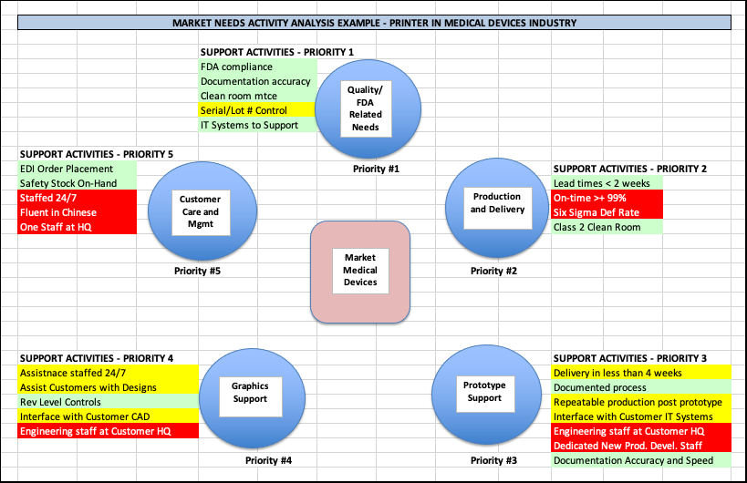

Summary

Understanding your customer/market needs is essential as it can help you identify the activities and operations that you need to excel at if you want to seriously compete in or dominate a market. Too many companies claim to be great at things, but in reality, it is all just another weak marketing ploy. Your customers will know if you excel at serving them well and word will ultimately get out to the market, so do what you say you do and do it well.

Try putting together one of these diagrams. Start with a well-defined market. If the initial market you try ends up being too broad, break it up. If you have one really large customer, do one just for that customer. At one company where we did this analysis the market was cardio rhythm devices, or pacemakers. This market included Medtronic, St. Jude, Boston Scientific and Guidant. Instead of a market-based analysis, we did one for each company because the needs varied by company, and each of them was large enough to warrant its own diagram.

In this case, the analysis helped quite a bit because at that time, Medtronic was getting out of manufacturing certain products and St. Jude still wanted to make their own. That made a difference in how we approached each of them and what products we offered and resulted in significant sales increases with each one. Because we clearly understood what they needed from us and focused our activities and operations accordingly.

_______

About the Author: Bob Krausert is the owner of STRATEX, a Twin Cities based firm that works nationwide. Bob is the author of the book, Extreme Lean, published in 2018. Bob has worked with over 60 printing companies, mostly mid-sized companies, but also with larger companies like Jostens and Banta, now part of RR Donnelly. During his career, Bob has trained over 12,000 people at both public and private events. Bob has been working with PIM since 2010, periodically providing educational seminars for its members. Bob can be reached at stratexlean20@gmail.com or by phone at 612-743-8706. If you would like to have a specific question or topic covered in one of the articles, feel free to make the suggestion.

