Decoding the Dynamics: A Comprehensive Analysis of the 2023 Wage + Benefits Trends in the Printing Industry

Wage + Benefits Reports Overview:

Within the complex terrain of the printing industry, the dynamic relationship of salaries, benefits, and overarching industry trends plays a pivotal role in molding both the current and future workforce landscape. The recently released “2023 Wage + Benefits Reports,” derived from the collaboration of 15 print association partners and their members, emphasize the critical need for comprehensive analysis and insights to drive business decisions related to personnel, organizational culture, and ultimately profitability.
The core of these detailed reports exposes more about specific industry recruitment and retention efforts. They are hailed as the most reliable year-to-year labor management reports in the graphics communications industry. With a historical backdrop dating back to the 1970s, these reports amalgamate data from nearly 400 companies across the country, boasting over 190,000 data points. Covering a spectrum of over 200 industry positions and job descriptions, the reports offer a granular understanding categorized by region, company size, and industry segments, including packaging, tag & label, digital printing, inplant, and union printers.
Analysis of Employee Count and Compensation Trends:
Looking at a comparison of averages over a three-year period the employee count data point unveiled intriguing patterns, emphasizing stability among smaller companies while showcasing a decline in the largest enterprises. Regional variations add nuance to the narrative, with North Central and South Central regions experiencing increases, while the North East and West witness decreases in employee count. The most significant change was in the South East where the average dropped considerably.
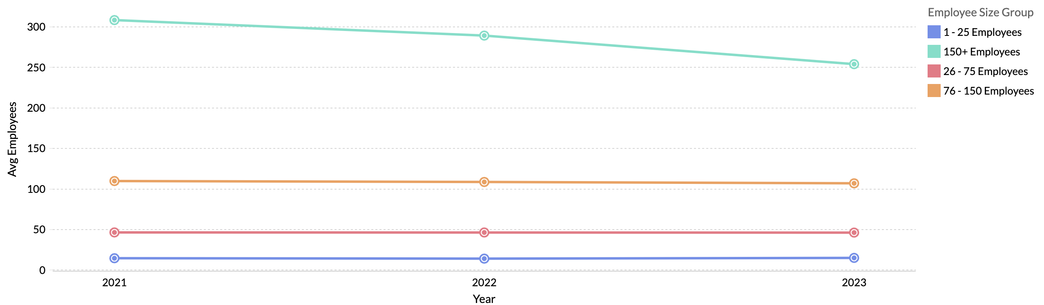
Delving into compensation trends, the reports show a fluctuating pattern in year-to-year overall compensation increases. Overall salary adjustments showed a dip from 2.5% in 2022 to 1.6% in 2023, while hourly compensation mirrored a similar trajectory, falling from 7% in 2022 to 1.6% in 2023. Projected wage adjustments at the national level reported an average at 2.7%, providing a glimpse into the anticipated shifts in the industry. These percentages paint a picture of where the labor market has come in the last several years. Further, the impact of baby boomers moving to retirement and workers not returning due to COVID has had a negative effect on the labor market. Automation was the plan to address the largest generation of boomer’s retiring; however, the affordability has become a deterrent due to several factors including increases in costs, but also increased interest in a short amount of time.
Year to year overall hourly compensation changes:
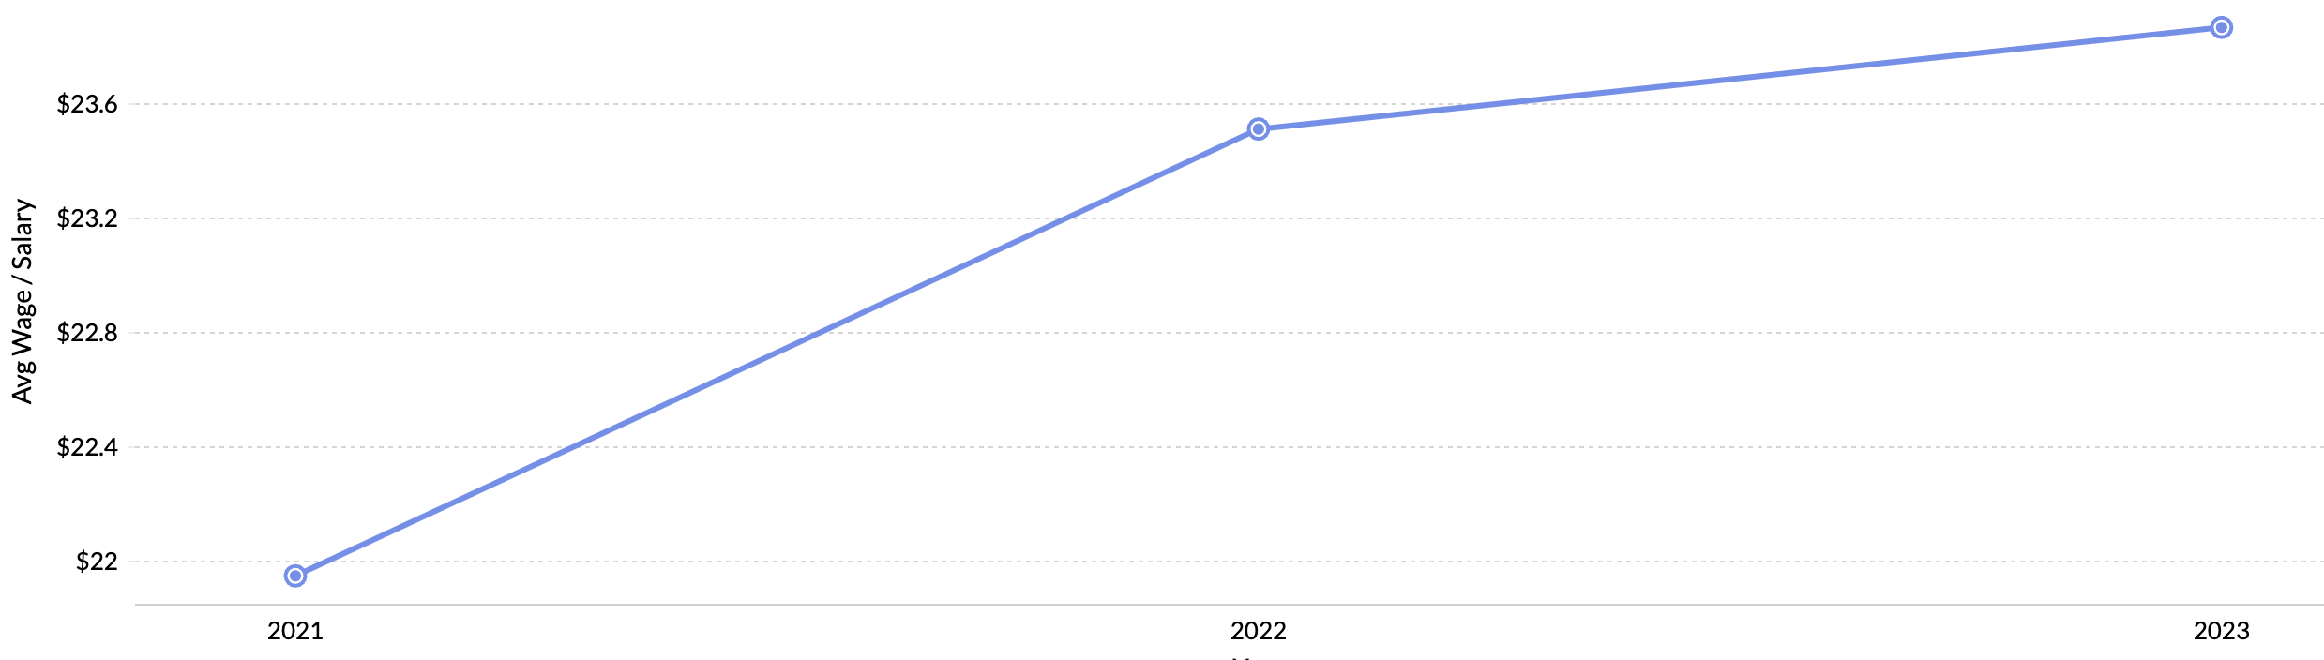

Predictions and Economic Context:
Anticipating future trends, the reports align their findings with the broader economic context, citing the November 2023 federal jobs report where average hourly wages, up 4.1% over the last 12 months, provide a benchmark against which the printing industry can gauge its own trajectory. Noteworthy is the stabilization of wage increases, a relatively low national unemployment rate of 3.9%, and a rise in total employment.
Detailed Examination of Industry-Specific Trends:
Beyond general trends, meticulous dissection occurs on specific industry positions and their corresponding wage changes. Compensation for Sales Managers, Marketing/Business Development Managers, Customer Service Managers, and HR Directors, which experienced a 9% average increase from 2020 to 2021, have leveled off. Similar patterns are observed in operational roles like Sheetfed Press Operators, Flexography Operators, Finishing/Converting, Mail/Fulfillment, Warehouse/Maintenance Operator positions.

Sheetfed Press Operator positions with largest increases from 2020 to 2021 at a 12% average leveled off or declined in 2022 but continued to rise in 2023 shown in the chart below.
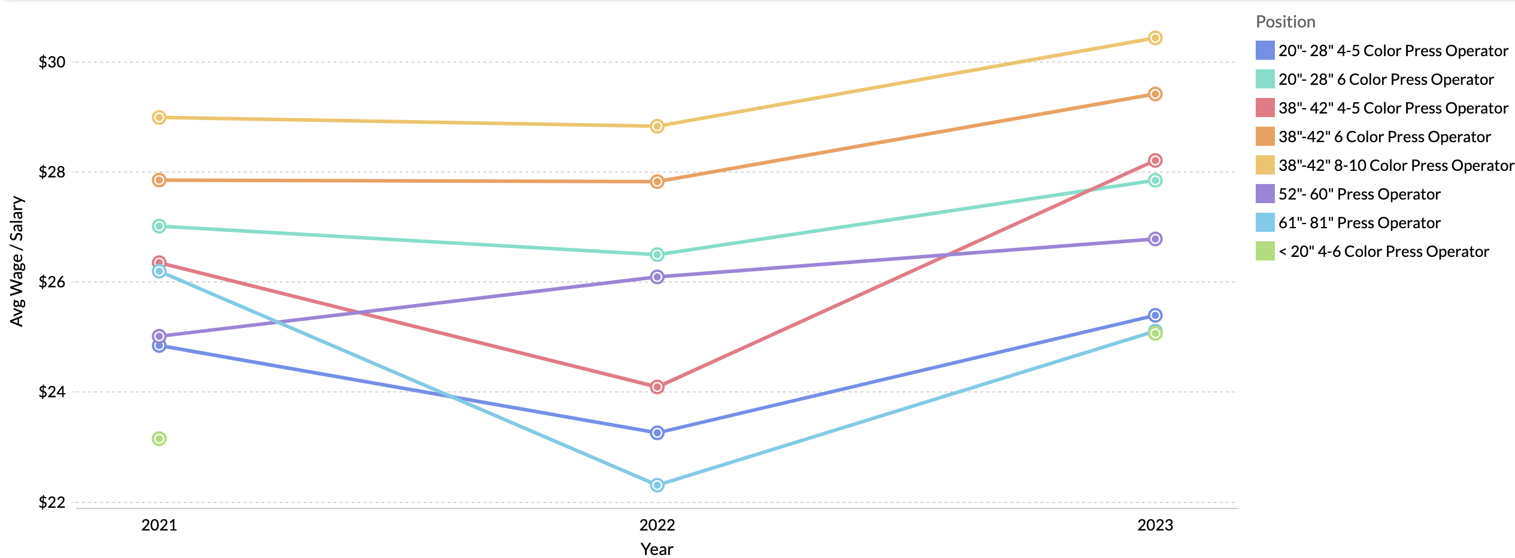

Finishing/Converting, Mail/Fulfillment, Warehouse/Maintenance Operator positions with largest increases from 2020 to 2021 at an 8% average leveled off.
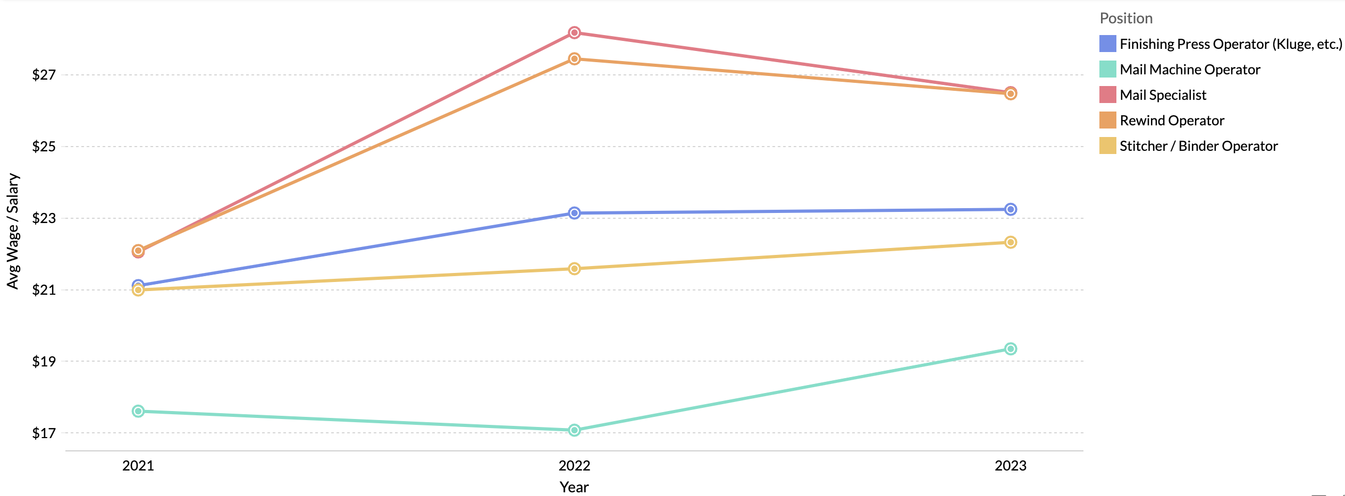

Regional Disparities in Work Structures and Policies:
Further evaluation through regional variations in work structures, policies, and incentives reveal considerable variations in number of production shifts across the nation. Notable is the dominance of companies with a single production shift in the South East and West, while the North Central region leads in companies with second and third shifts. Insightful details emerge regarding drug policies, time-off practices, workweek preferences, and overtime pay compensation.
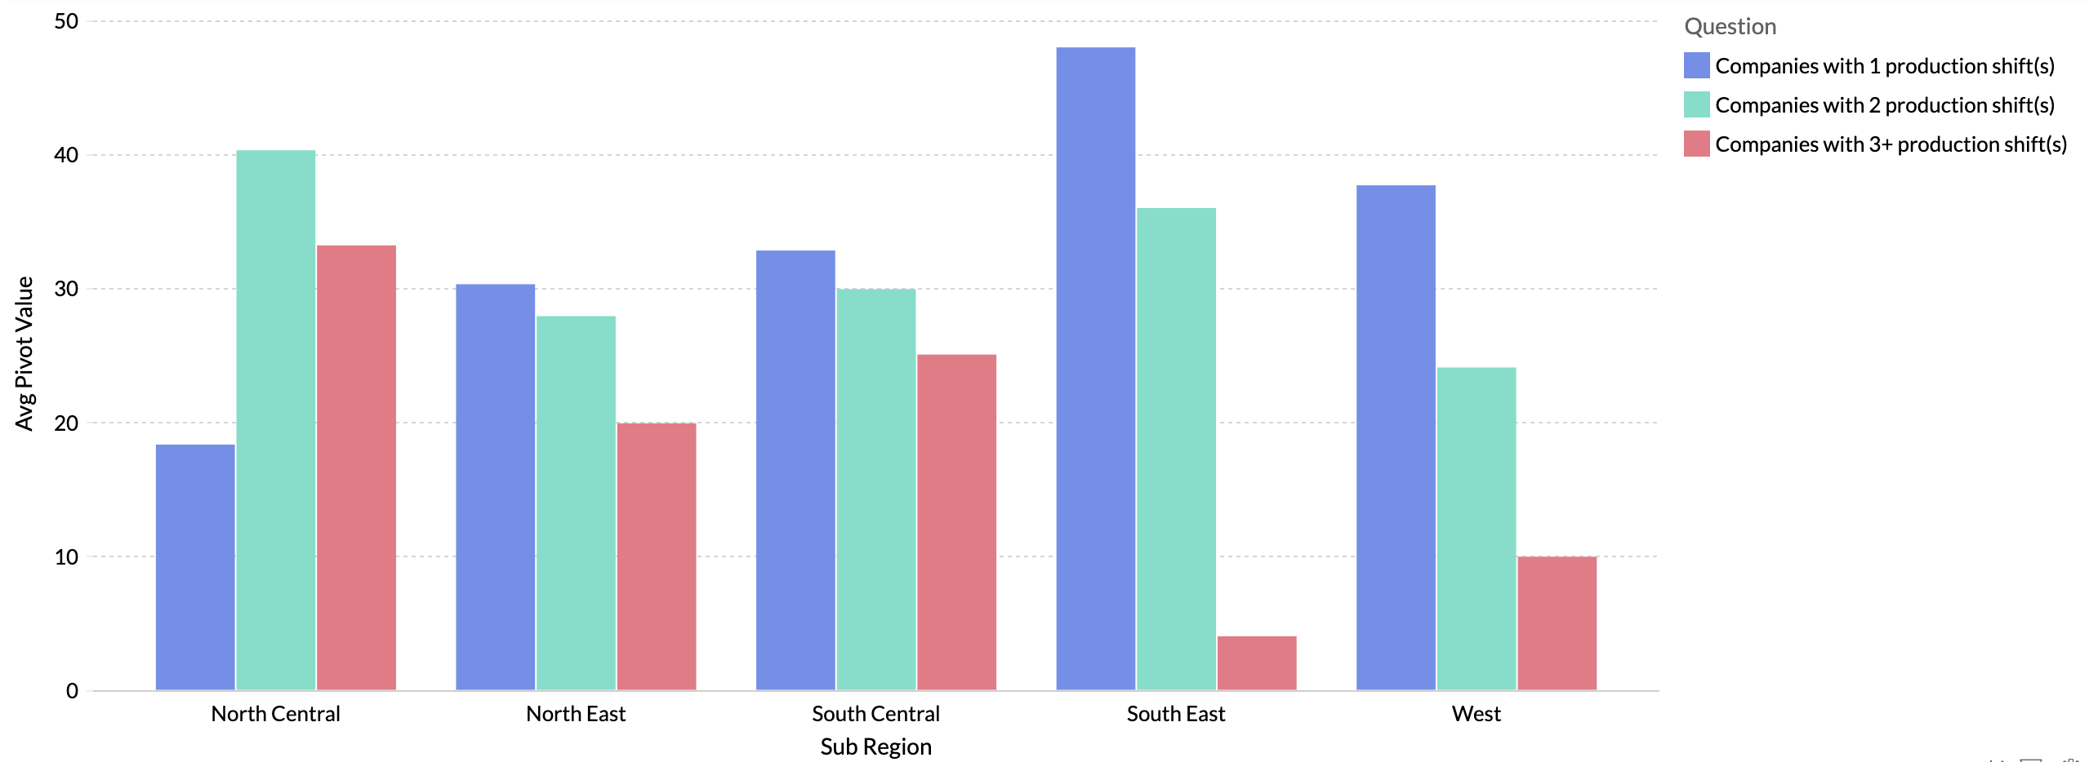

Comprehensive Review of Benefits and Economic Influences:
A comprehensive review of benefits covers vacation policies, personal time off (PTO) accumulation, health insurance offerings, and retirement plans. Regional disparities are evident, with the South Central region leading in one-week paid vacation after one year of service, and the West outpacing in employer-covered health insurance. Retirement plans, including 401(k) matching and profit-sharing options, vary across regions. Incentives, such as bonuses and gift cards, are explored as motivating factors for employee retention. Today’s economic influences must be recognized and include inflationary pressure, election year dynamics, growth in mergers, acquisitions and consolidations, skilled labor job market trends, and supply chain issues.
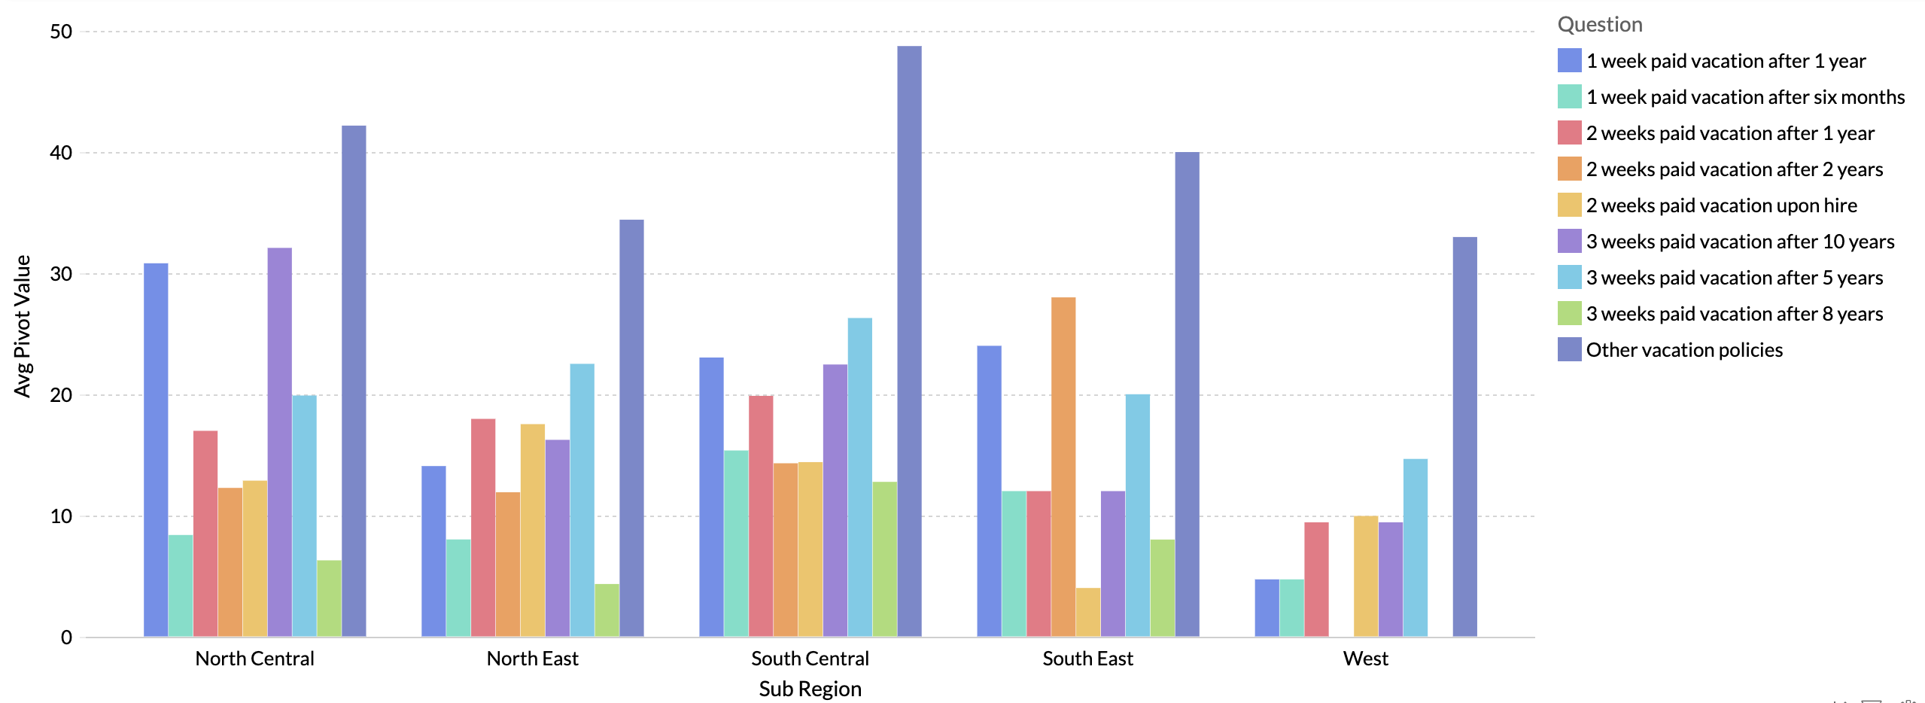

Health Insurance – Average % covered by employer
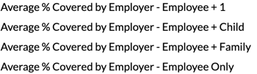
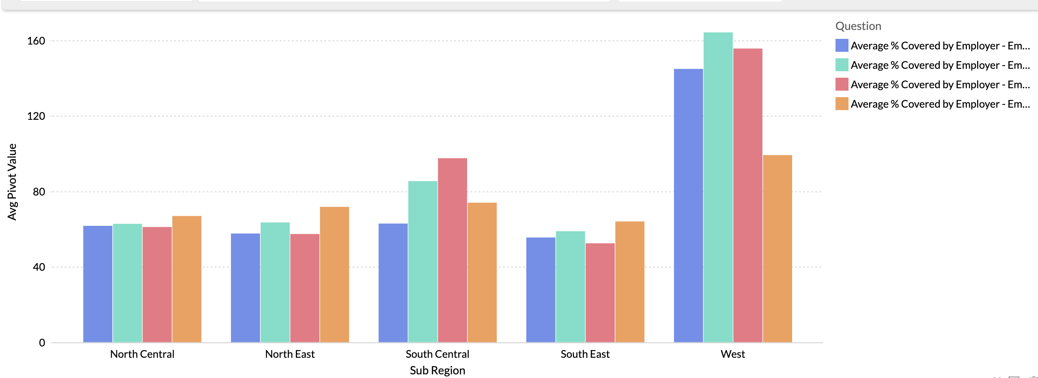

While there is consistency in survey participation year-over-year, it is important to note that the data subset of participating companies is not identical which affects these comparisons. Even though the companies that change are a fairly small percentage, it does play a part in the analysis.

Conclusion:
The "2023 Wage + Benefits Reports" not only dissect the current state of compensation packages in the printing industry but serve as a roadmap for industry stakeholders navigating the complex terrain of many outside influences and workforce dynamics. As the industry continues to evolve, these insights provide a valuable compass for informed decision-making and strategic planning.

A Roadmap to Utilizing “2023 Wage + Benefits Reports” for Improved Wage Management, Recruitment and Retention:

Printing firm leaders are encouraged to dig into the reports deeper and utilize the rich content to form budgets and generate a long-term plan. Recommended first steps to bringing this data into strategic planning for 2024 starts with creating a list of every employee position in your firm, maybe on a spreadsheet. For each position, include what your firm pays for each position, including things like starting pay and top pay. If you have historical data of what pay was offered previously this is valuable to add. Next, analyze the data in these reports and identify relevant points for each position. Reflect on insights that impact each role. From this approach, you will build a foundation of knowledge comparing your firm’s compensation rates to industry averages. This is more than making a list. It’s analyzing and recording relevant material from this report.

Then, as part of a budgeting process, use the foundational knowledge built into your list to determine needed changes in both starting pay and top pay for each position. Once you have determined this for each position, systematically apply those guidelines. For instance, consider reviewing every pay rate once a year, the same month every year. Then, at the mid-point between two annual pay rate reviews, consider employees who are not paid top wages for each position. For example, you might review the overall wage picture in December and review those who are under top pay in June. Firms that apply this or a similar systematic approach experience at least two related benefits: their wage management approach has more credibility among employees, and employees question their wages less often. These benefits as well as a variety of others can make a positive impact on strategic planning and efficiency.
Teresa Campbell, PIA MidAmerica President and Annual Wage + Benefits Program Director

