**Motivating Your Employees:**

**Uncovering Expectancies and Unleashing Their Performance**

***Dr. Ralph Williams\****

Associate Professor

***Dr. Dan Morrell\****

Professor

*\*Jones College of Business,*

*Middle Tennessee State University*

Motivating your employees is vital to firm performance. If your employees are motivated, they care more, do more, and are more committed to your firm. Expectancy Theory (from Victor Vroom, Yale School of Management Professor, in 1964) points to three crucial questions you should consider when seeking to motivate employees.

After leading printing companies, I entered academia and taught management. From teaching motivation, “Expectancy Theory” resonated with me. When consulting a company, we applied Expectancy Theory. I will share that story after briefly explaining this relevant theory.

Expectancy Theory is based on the relationships between three elements.

* Effort (*E*) – the effort an individual puts into completing a task and performing well.
* Performance (*P*) – the performance that results from effort.
* Outcomes (*O*) – rewards from performance and the value of those rewards

Those relationships prompt three questions in employees. To these questions, Vroom applied three terms: Expectancy, Instrumentality, and Valence.

* (*E→P,* Expectancy) If I invest effort into this task, can I perform well?
* (*P→O,* Instrumentality) If I produce high performance, will I receive the outcome?
* (Valence) Do I value the potential outcome (reward)?

*See the illustration below.*

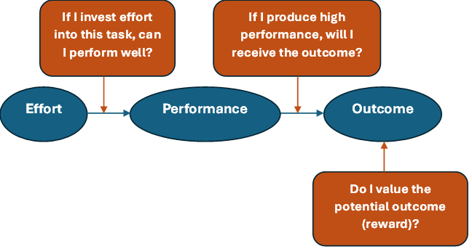

The company I consulted had a veteran salesperson with many years of success. However, that salesperson had stopped prospecting and seeking new business. All three of the Expectancy Theory questions affected that salesperson’s motivation to pursue new business.

*If I invest effort into this task, can I perform well? (E→P)* *–* Technology was changing (and it still is). And this salesperson did not feel he had the knowledge needed to promote the company's new products and services. To address this, the company engaged in ongoing “product training” for their sales team. Training like this helps increase an employee’s expectancy to perform well.

*If I perform well, will I receive the outcome (reward)? ( P→O) –* The company had some flaws in its sales compensation plan. Without going into detail, a salesperson sometimes received more commission than was expected after a printing job was shipped. But sometimes, a salesperson received less commission than was expected. Indeed, multiple times a year, a salesperson would not receive a commission for a job they sold. To address this, the company fixed its sales commission plan. Trust is a huge component of instrumentality. If an organization has failed to deliver on promised rewards in the past, employees are less likely to try to attain promised rewards in the future.

*Do I value the potential outcome (reward)? (Valence) –* Again, the salesperson who is the focus of this story had a long history of success. Therefore, he was in a comfortable personal financial position. Was earning more commission good for him? Yes. But not as valuable as in previous times. The company started to emphasize intangible outcomes (recognition) in addition to tangible outcomes (commissions). When someone in their sales team identified an excellent prospect or closed a deal with a new customer, the leadership team publicly recognized that accomplishment. This is an excellent example that valences, or the amount of value an employee places on a reward, differ among employees. Therefore, you may need to try different rewards (or recognition systems) or do a brief survey to see what would really motivate your team members.

These steps, which align with Expectancy Theory, increased that salesperson’s, and their sales team’s, pursuit of new customers.

Printing company leaders, you might consider these questions when considering the motivation of your sales, production, and office teams.

* Do they believe they can perform well? Do they have the needed knowledge and resources?
* If they perform well, are they confident they will receive the implied outcomes (rewards)?
* Do they value the implied outcomes (rewards)?

Here are some other thoughts. To motivate an employee, all three questions must have a “YES”! If one is a “no,” motivation is minimal. You should consider these questions from both a “group” and an “individual” perspective. Apply what’s most effective in motivating the team. But remember that everyone is different. You might have to do something a little different for a specific individual. Always consider both tangible and intangible outcomes (rewards). Lastly, you might discuss these concepts with your management team; they might apply them.

Printing company leaders, we hope this knowledge expands your view of how to motivate your valuable team members!

If you have any questions or comments, email Ralph at [ralph.williams@mtsu.edu](mailto:ralph.williams@mtsu.edu)